Installation
The user will need to install separately the compiler tools (LPCXpresso) and the PE0003 drivers, see PE0003 user manual.
The EC0003 installation includes the ‘C’ libraries. Run ‘EC0003Installer.exe’
The installation has the option of creating shortcuts in the start menu and the desktop.
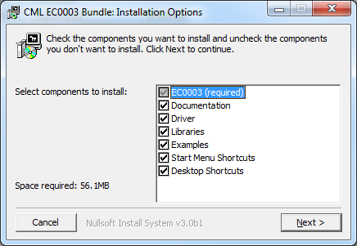
The libraries, documentation, examples and pe0003 driver FILES are installed in a folder called CMLMicro under ‘Documents’.
C:\Users\xxxx\Documents\CMLMicro
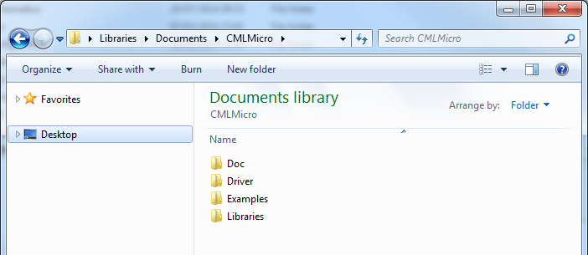
Once installation is complete read the document:
C:\Users\{username}\Documents\CMLMicro\Doc\GetStartedPE0003.docx

Known Issues

- Library documentation is slightly out of step with libraries in the following respects:
  - PDSPn references.
Functions documented as:
Gui_LoadFunctionImageCbus_PDSP4B(CBUS2, ActiCode, &ID, &Ver);
Have now had the PDSP references swapped for actual device top mark. In this example PDSP4B can be replaced with either CMX724x or CMX734x
  - Activation codes
GUI load FI functions (mon_fi.h ) documented as:
Gui_LoadFunctionImageCbus_PDSP4B(CBUS2, ActiCode, &ID, &Ver);
Do not currently take the ‘ActiCode’ argument. For now, when executing a project with EC0003, the activation code has to be supplied by the user when prompted.
- File paths
Where a write file is specified within a ‘C’ project the full path must be given, Otherwise EC0003 will generate this error:
